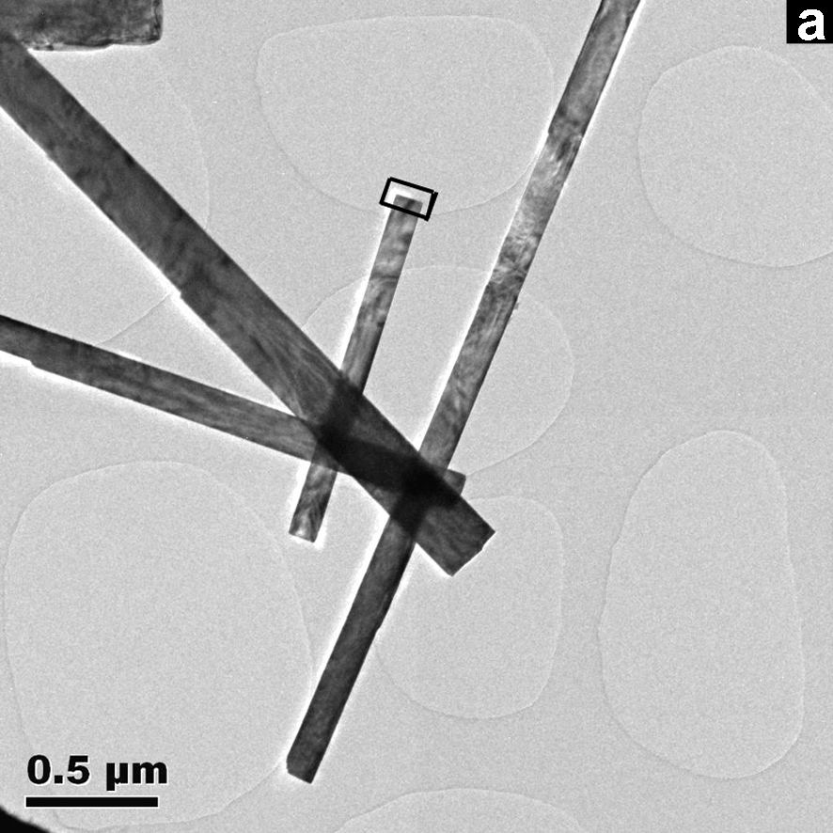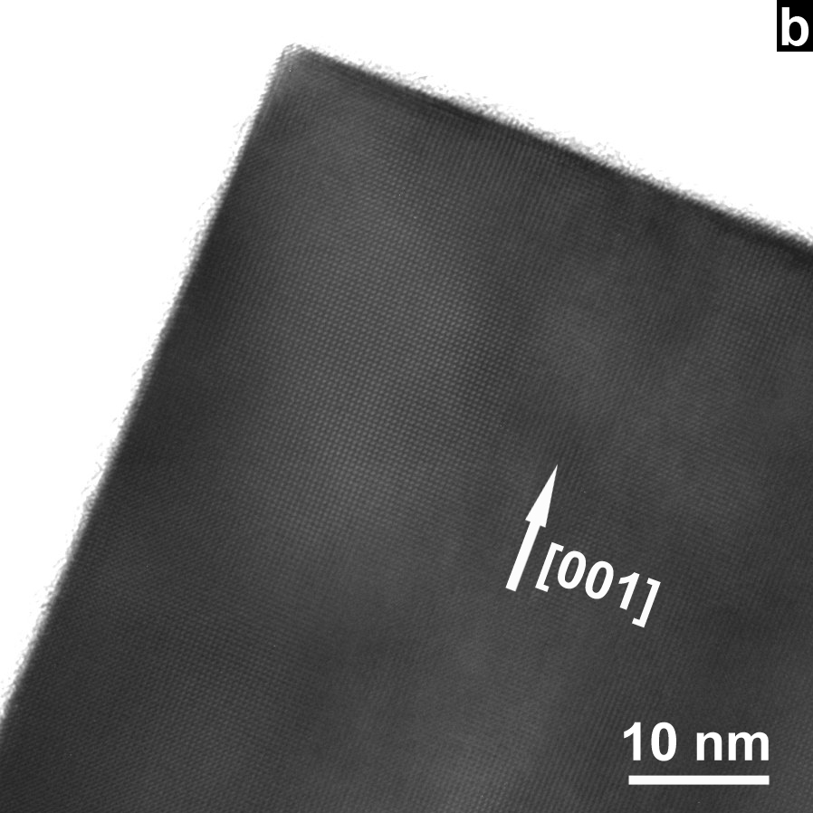

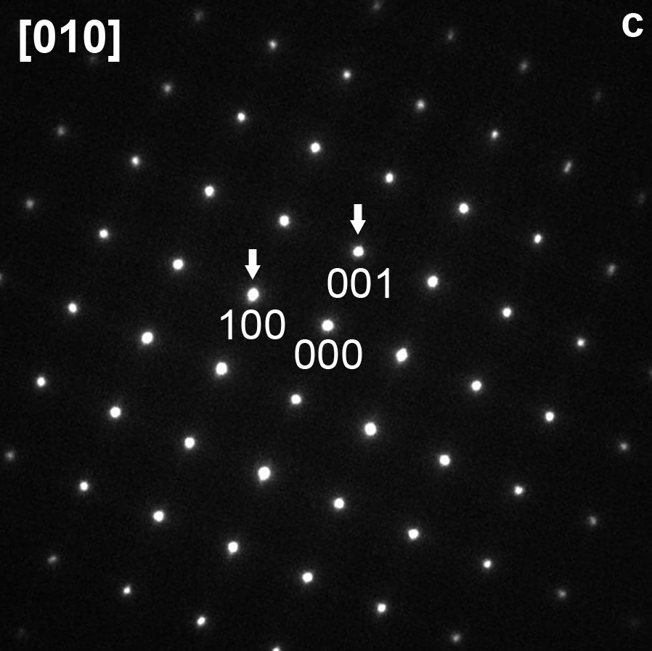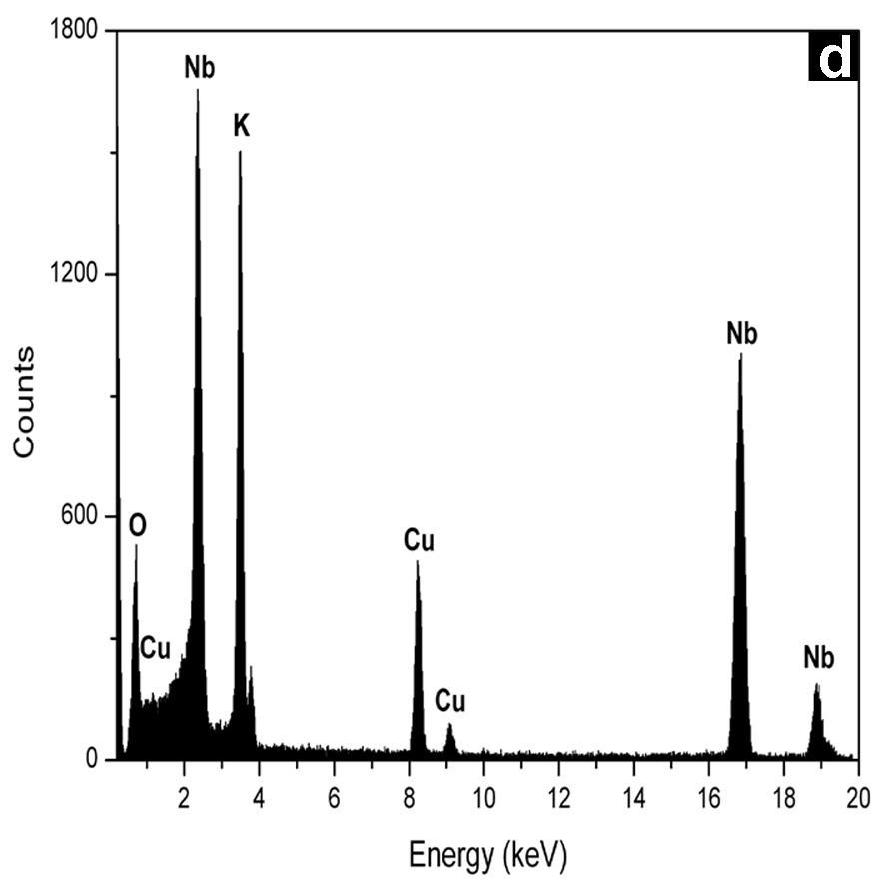

Fig. 4
Fig.4b maybe the present HRTEM magnification was too low and hard to see “atoms”…. Do I need to make a new enlarged one? Anyway I will try and save another one here soon!

