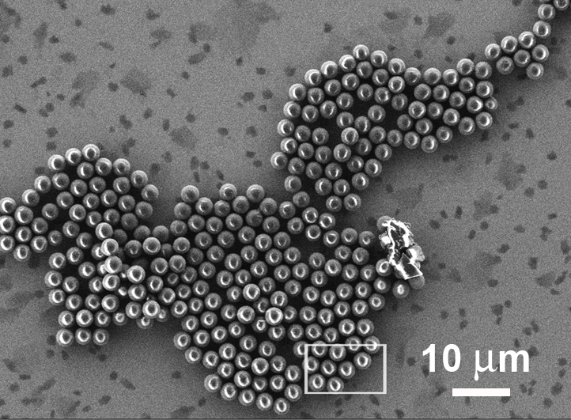
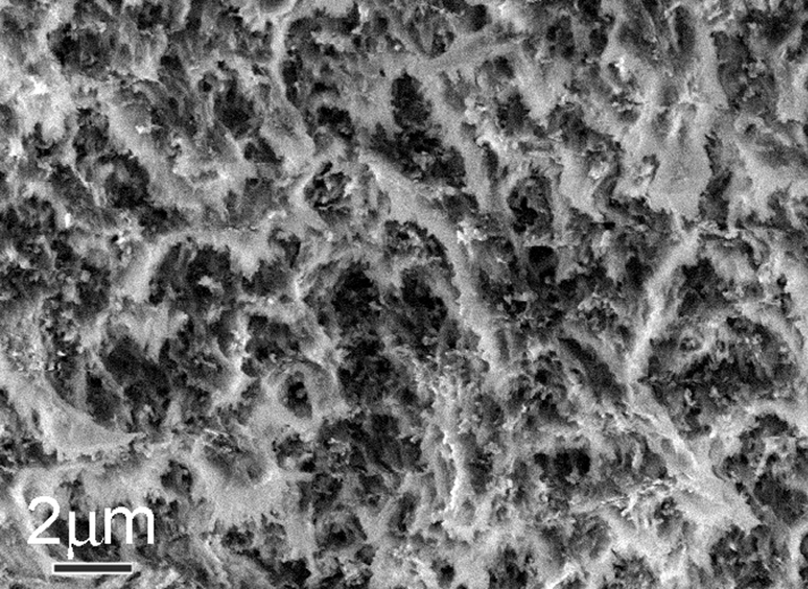

FIG. 1. VPSEM micrograph of a nano compo-site polymer under the 8 Pa gas pressure at 5kV.  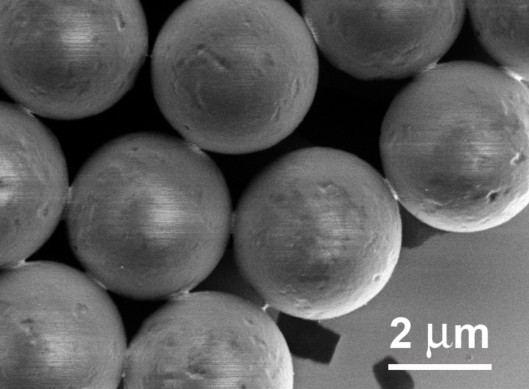 | FIG. 2. LVSEM micrograph of the polymer particles at 3 kV and WD of 3 mm.  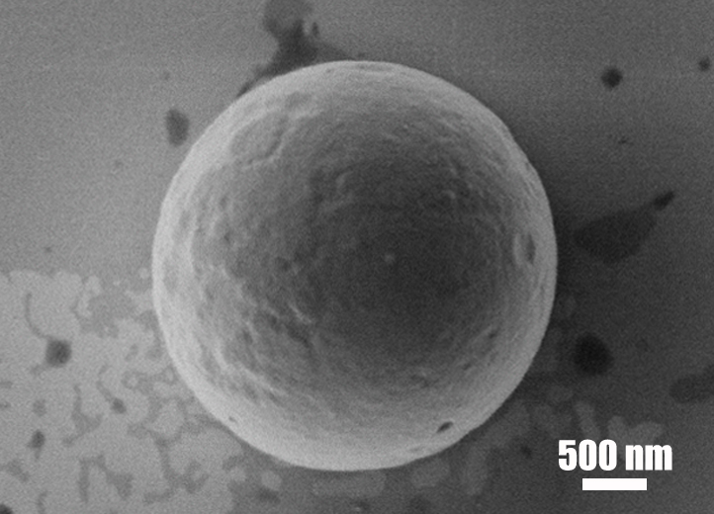

FIG. 3. LVSEM micrograph of the polymer particls at 1kV and WD of 1 mm.  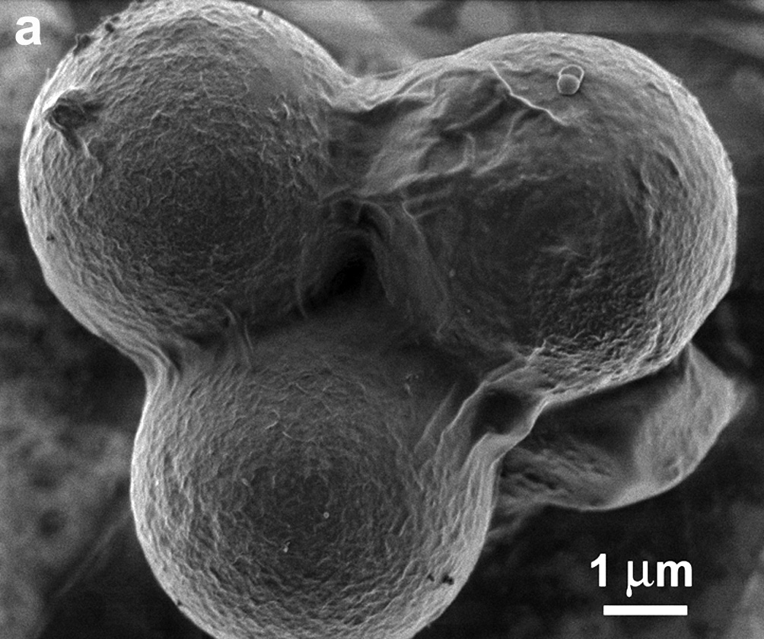 | FIG. 4. LVSEM micrograph of the polymer particles at 0.5 kV and WD of 1 mm.  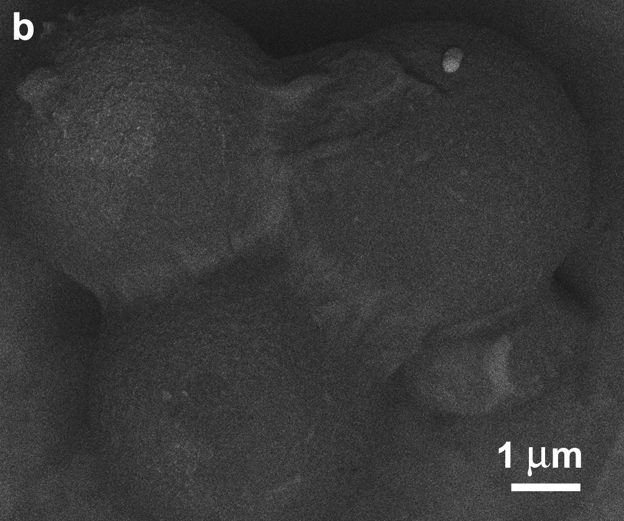

FIG. 5. LVSEM micrographs of the polymer particles with Au-Ni metallic coating. (a) In-lens SEM image at 0.5 kV and WD of 1 mm. (b) Low-loss BSE image of (a) at the filtering grid of 330 eV.

