Characterization of morphology and microstructure of different kinds materials at the NTNU EM Lab

Y.D. Yu, T. Nilsen, J. Hjelen and J.K. Solberg

Lab of Electron Microscopy, Department of Materials Technology, Norwegian University of Science and Technology (NTNU), N-7491 Trondheim Norway

yingda.yu@material.ntnu.no
Keywords: SEM, TEM, characterization

Lab of Electron Microscopy (NTNU EM Lab) has been establishing and responsible for the electron microscopy facilities to assist NTNU multi-discipline materials science research. Through many year efforts with our academic competence, the EM lab is well ready for serving the research activities from various academic departments in the university. Here we present several recent characterization examples from different kinds materials in the laboratory experiments.

Figure 1(a) shows a digital transmission electron microscopy (TEM) micrograph of Al-Mg-Si alloy from our JEM-2010 TEM which is equipped with a sensitive CCD-based camera. Further semi-automatic particle analysis by using imaging software could give the detailed information of hardening phase distribution in this commercial Al alloy, which are important parameters for understanding the microstructure–mechanical property relationship in the traditional light metal industry in the country. Meanwhile, the microstructure development of the bulk nanostructured materials (BNMs) from this commercial alloy produced by severe plastic deformation (SPD) [1] is revealed at atomic level by the high resolution TEM as shown in Fig. 1(b). Catalyst particle characterization is the basic for catalyst production and future performance. Figure 2(a) show a scanning electron microscopy (SEM) micrograph from our Zeiss in-lens detector, in which a carful sample preparation was employed to well disperse particles on the same plane for archiving nanosacle resolution at a shorter working distance (WD). Further high-resolution TEM image of Fig. 2(b) confirmed the full crystallization of individual particles, which gives a whole range microstructure characterization of this catalysis system [2]. Figure 3 shows a variable pressure (VP) SEM micrograph of the nano-composite polymer, in which the SEM gas pressure was carefully controlled to form the thinnest conducting ionizing layer for getting the best VP SEM resolution. Without using conducting coating, the nano-enhanced particles are definitely identified in the VP SEM mode [3]. TEM image of PbTiO₃ perovskite in Fig. 4 shows the fibber grown crystallography relation for further understanding growth mechanism. Similar method is also used for many other nano-synthesis materials in the Lab. The EM Lab is also involving the intensive research programmes for electron back scatting and electron microprobe analysis, and some relevant results are also presented in this conference.

- M. Liu, H.J. Roven and Y.D. Yu, Zeitschrift für Metallkunde 3 (2007), p. 184.
- T.J. Zhao, D. Chen et al., Norwegian Patent Application (2008).
- L. Shao, PhD Thesis, Norwegian University of Science and Technology (2008).
- G. Wang et al. (2008).

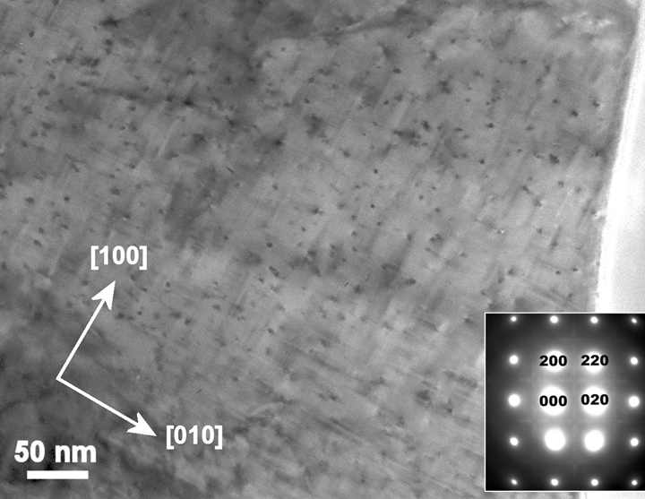 | 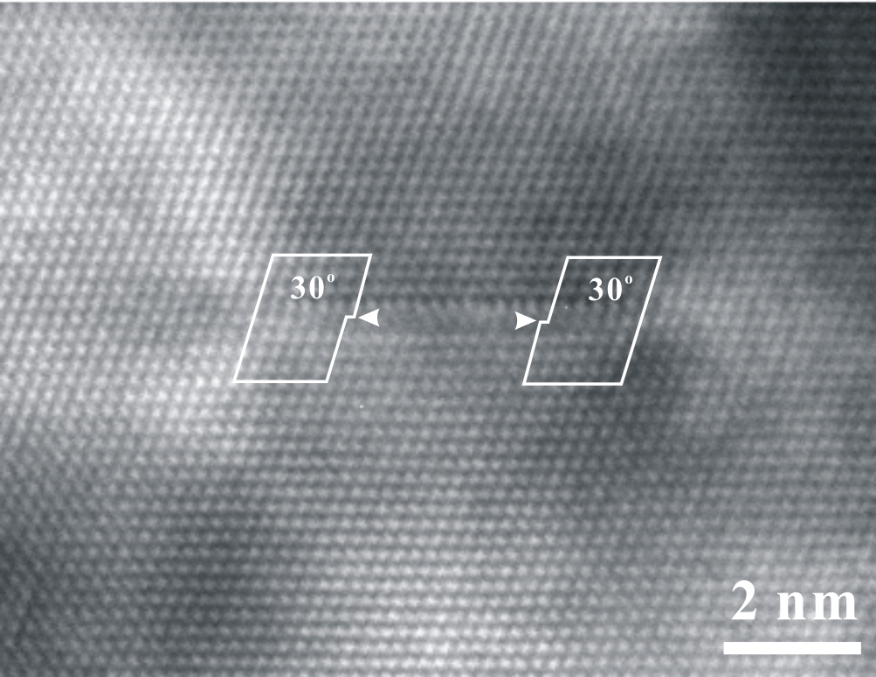
Figure 1a. High-resolution TEM image of the hardening phases distribution in a commercial aluminium Al-Mg-Si alloy. | Figure 1b. The screw dislocation dissoci-ated into two Shockley partials connected by an intrinsic stacking fault in SPD Al.
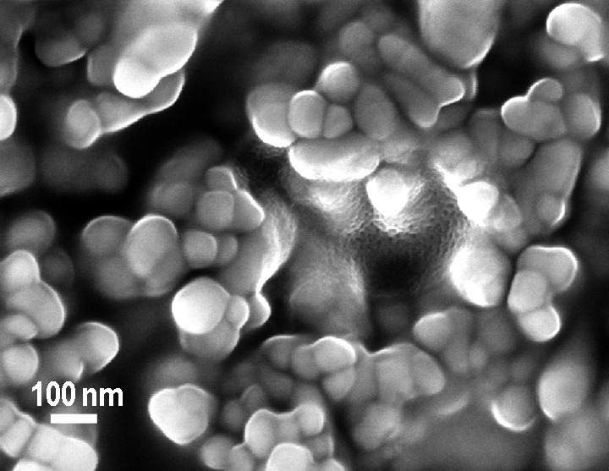 | 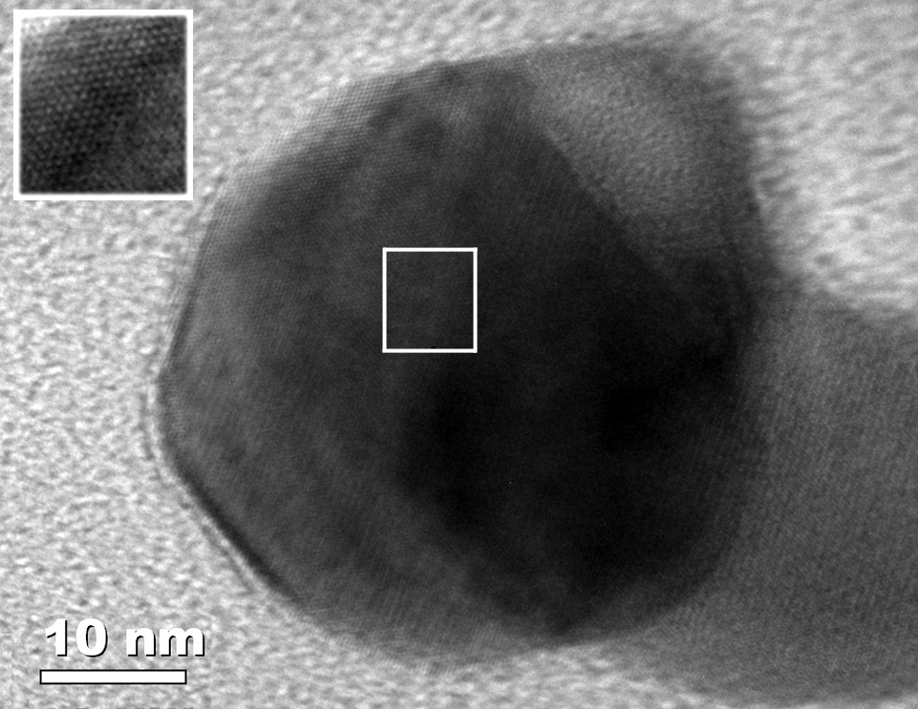
Figure 2a. SEM micrograph of the catalyst particle distribution at the WD of 4 mm. | Figure 2b. High-resolution TEM image of one catalyst particle in Fig. 2(a).
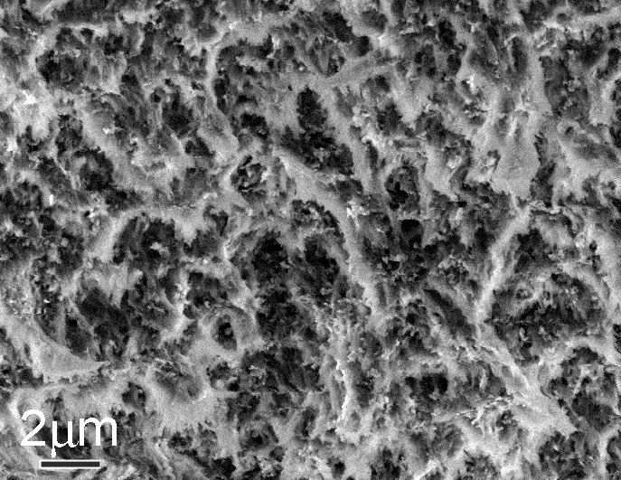 | 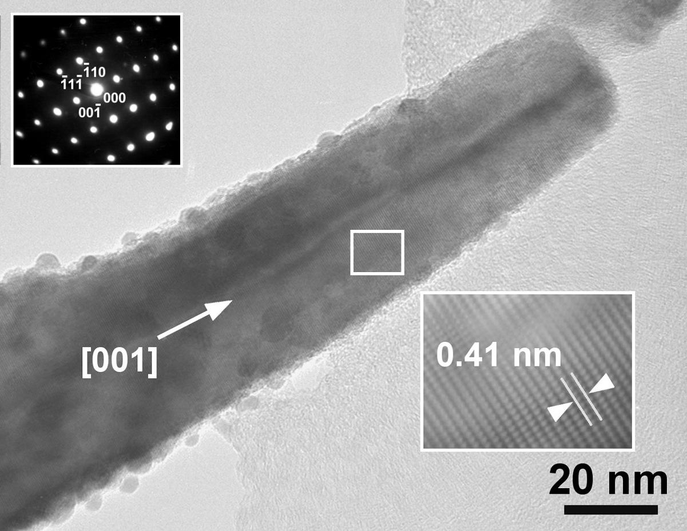
Figure 3. VP SEM micrograph of the nano composite polymer at the 8 Pa gas pressure. | Figure 4. Selected area diffraction pattern and TEM image of PbTiO₃ perovskite.

